SIMATS ENGINEERING
ASSESSMENT TOOL 3

COURSE NAME: Artificial Intelligence COURSE CODE: CSA17

COURSE OUTCOME COVERED

CO3: Apply AI basics such as intelligent agents and uninformed search methods to solve problems effectively. (BL3)

Assessment Tool Weightage: 40%
Multiple Choice Questions

Code of Conduct:

I V. Venkata Susheel Chowdary (192472060) (Name / Reg No) certify that this submission is my original work and that I have adhered to the guidelines specified for this assessment.
I understand that any violation of academic integrity rules will result in disciplinary action.

Susheel
Signature of the student:

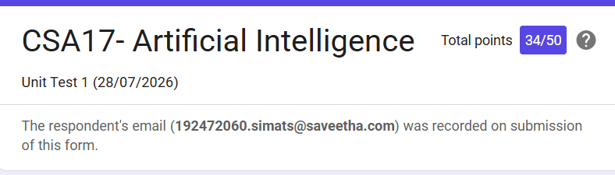

Rubrics
COURSE NAME: Artificial Intelligence COURSE CODE: CSA17
QUESTIONS: 2 Duration: 45 Minutes Total Marks: 20

Criteria | Weightage | Q1 (10) | Q2 (10) | Total Marks (20)
Understanding of Concepts | 25% (2.5) | /2.5 | /2.5 | /5
Explanation | 25% (2.5) | /2.5 | /2.5 | /5
Application | 20% (2) | /2 | /2 | /4
Organization | 15% (1.5) | /1.5 | /1.5 | /3
Accuracy | 10% (1) | /1 | /1 | /2
Clarity | 5% (0.5) | /0.5 | /0.5 | /1
Total per Question | 10 Marks | /10 | /10 | /20

